Instructions on how to access QUIZSTAR
- Go to the website at http://quizstar.4teachers.org/
- Student Login Page Student Site
- Once you are there fill in your information: Classname: HBiology11_12C
  - Username
  - Password

You will see:
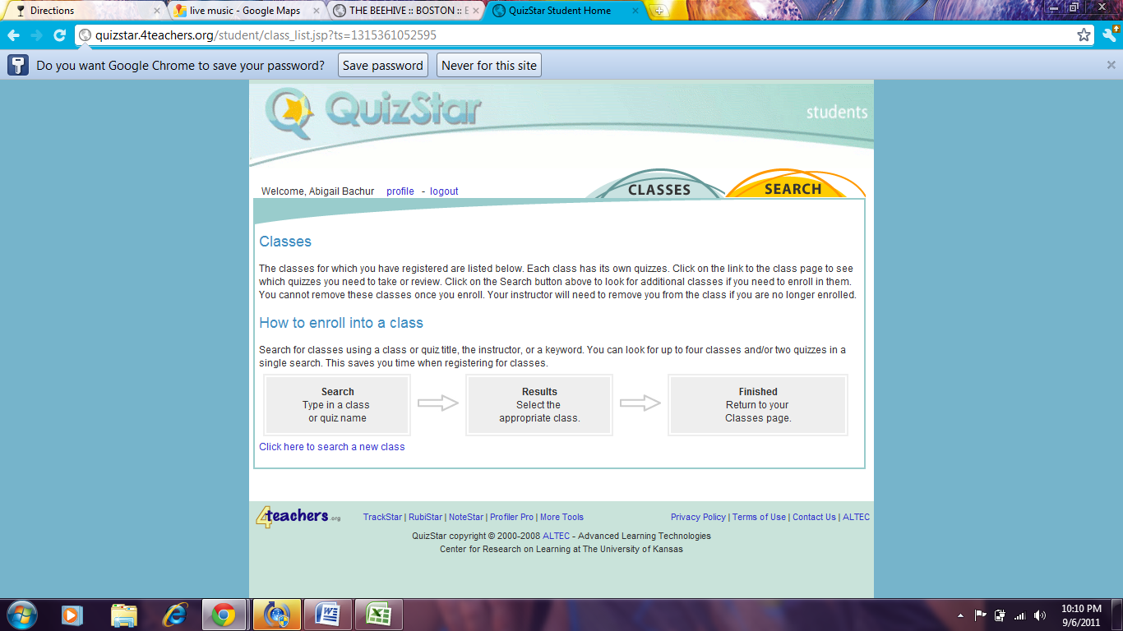

- Click on “Search”
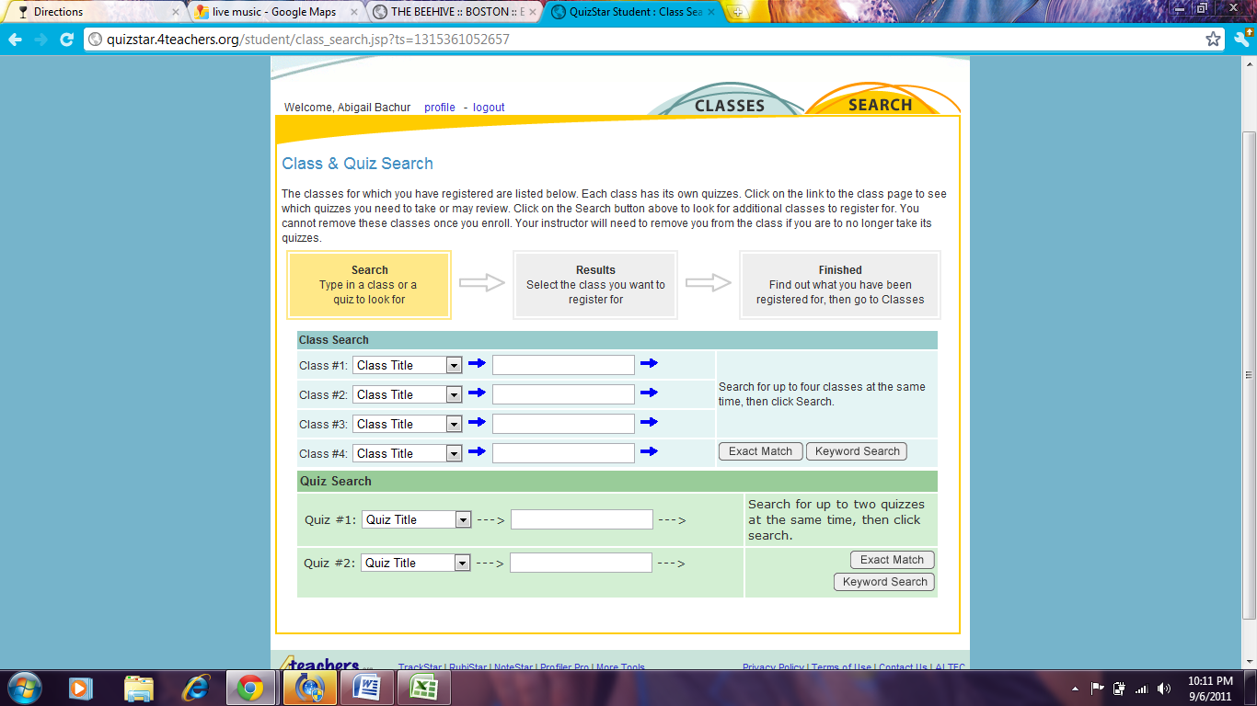

- Next to Class #1 Click on “Teachers Name” and Fill in Carrette
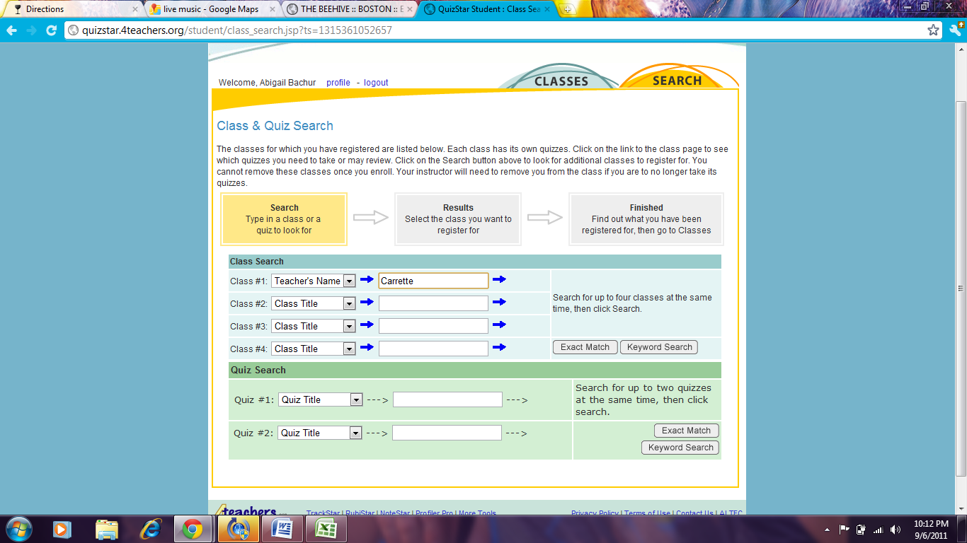
- Click on Exact Match
- Find your class, click on it and hit “Register”
